

**VNM CONFIGURATOR USER MANUAL FOR FIRMWARE 1.x**

Contents

**About us** 2

**I. Wheelbase Configuration** 3

**II. Shifter Configuration** 3

**2.1. LED Effects Customization** 5

**2.2. Calibrate the shifter** 6

**2.2.1. Calibrate h-pattern** 6

**2.2.2. Calibrate sequential** 6

**2.3. Set the shifter’s thresholds** 7

**2.3.1. Set the h-pattern thresholds** 7

**2.3.2. Set the sequential thresholds** 8

**2.4. Troubleshoot** 8

**2.4.1. Cannot change the gear** 8

**2.5 Update firmware** 9

# **About us**

VNM Simulation JSC comes from Vietnam. We are a new simulation equipment manufacture. We aim to deliver high simulation equipment and help an active online DIY community where people can discuss how to make high quality simulation equipment by themselves when using VNM Simulation’s firmwares (these are free for personal use).

Download the lasted UI/Firmware on this repo:

<https://github.com/hoantv/CarSimulatorFirmware>

the repo includes:

* Wheelbase firmware
* Shifter firmware
* UI

Will add pedal, handbrake, steering wheel soon.

# **I. Wheelbase Configuration**

Will be updated

# **II. Shifter Configuration**

Connect the shifter via USB Type B to PC, the icon shifter will change from orange to green. It indicates that the shifter is connected to PC. Go to shifter Tab.

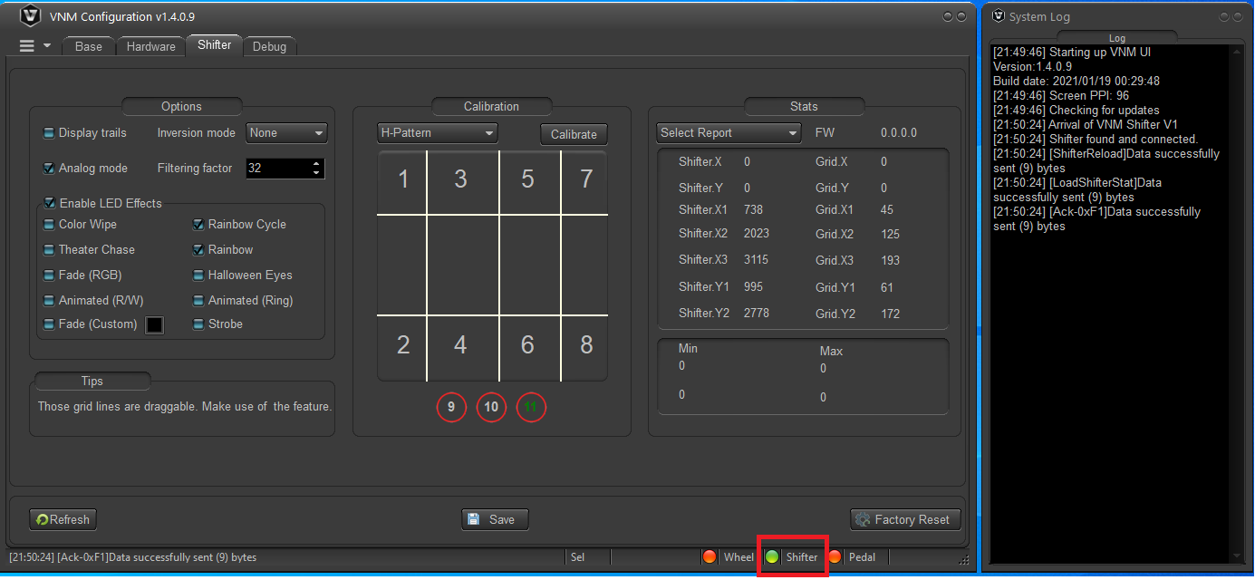

There is 2 options Analog Mode and Inversion Mode that are used for the first setup before the shifter is packaged. So please don’t modify 2 option.

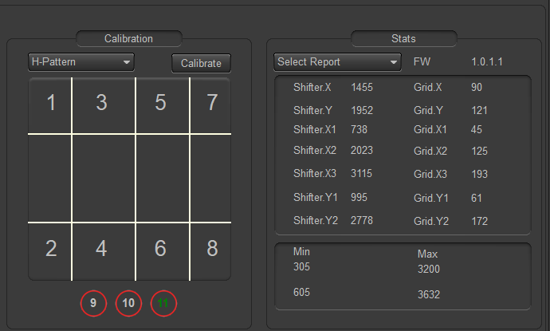

* Calibration Groupbox:
  + H-Pattern/Sequential combobox: Based on position of a switch, behind the shifter. The UI detect which mode is in use.
  + Calibrate button: Usually, you don’t need this option, it is used for the 1st setup of the shifter when uploading firmware or factory reset. It used to set minimum, maximum of each shifter axises (X, Y axis).
  + The grid shows the gear area. When the shifter’s rod is in an area, the number in this area will turn green. It indicates that a gear change to this gear number.

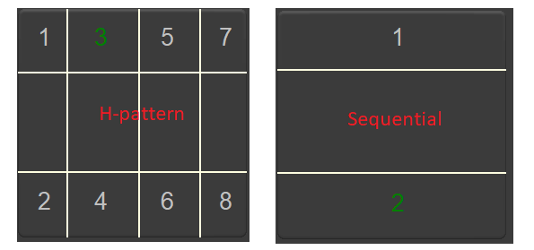

* + Three circles 9, 10, 11: Cycles 9,10 indicate the positions of the truck’s knob button if use. The cycle 11 indicate switch mode position.



* Stats Groupbox
  + Select Report combox: use for configuring the thresholds (X1, X2, X3, Y1, Y2) for each shifter gear. It must in “Select Report” to make the shifter work. “Shifter Configuration” is used to configure the thresholds.
  + FW: shows the version of shifter firmware.
  + Min-Max: show min value, max value of X, Y axis after calibration.
* Refesh button: Get the current shifter configuration
* Factory Reset: To reset to default configuration.
* Save: To save config to the shifter.

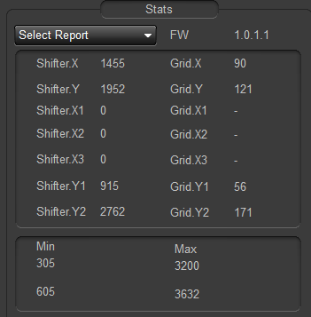

## **2.1. LED Effects Customization**

* Enable LED Effects: There are 10 effects for LED, 9 effects were fix colors and Fade (custom) allow to change color. After changing this option, please re-plug the shifter.
* Check: Enable LED Effects
* Uncheck: Disable LED Effects
* Check / Uncheck each LED effect options to enable/disable each LED effects.
* Fade (custom): click to square button (1), a pop-up is display. You can choose available colors in (2). To add new color by click to edit button (3). In (4) you can click anywhere to choose a color that you like and click add to add new color to the list more options. After choosing a color, click OK button on popup.
* After changing this option, please re-plug the shifter.
* When shifter reconnect, it will play new effects/color that you chose before.

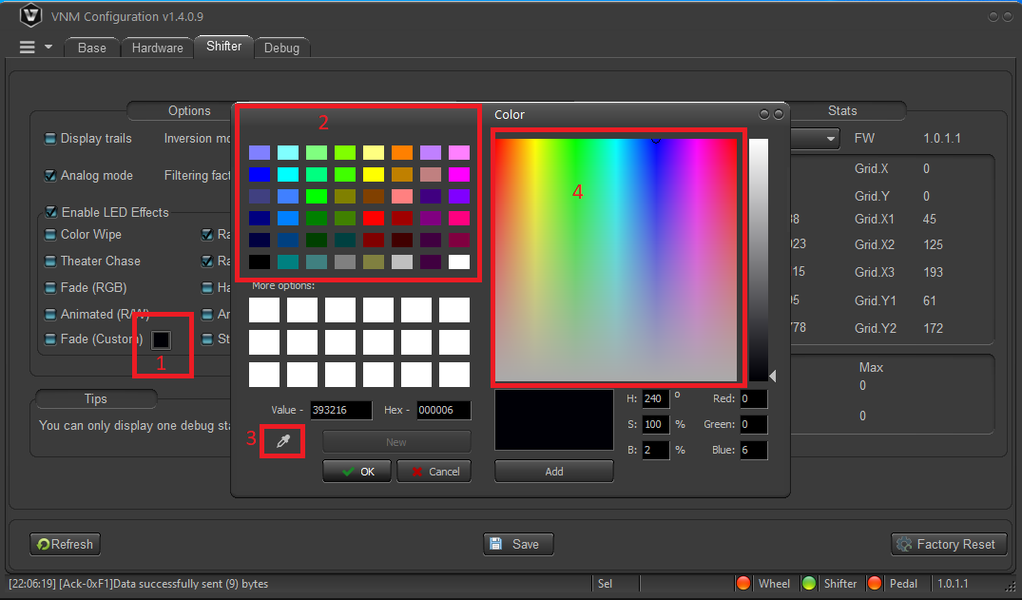

## **2.2. Calibrate the shifter**

Note: Must calibration for each mode.

### **2.2.1. Calibrate h-pattern**

It is uses to find the min-max value of X, Y axis. Only use at the 1st time uploading firmware or click factory reset button.

* Step 1: put h-pattern plate onto the shifter.
* Step 2: click “calibrate” button, it will turn into “finish”, a instruction popup is display, click “ok” button.
* Step 3: Switch the shifter to the top-most, bottom-most, left-most, right-most. Do it several times.
* Step 4: Click “finish” when you’ve done.
* Step 5: click save to persist calibrate information to ROM

### **2.2.2. Calibrate sequential**

It is uses to find the min-max value of Y axis. Only use at the 1st time uploading firmware or click factory reset button.

* Step 1: put the sequential plate onto the shifter.
* Step 2: click “calibrate” button, it will turn into “finish”, a instruction popup is display, click “ok” button.
* Step 3: Switch the shifter to the top-most, bottom-most. Do it several times.
* Step 4: Click “finish” when you’ve done.
* Step 5: click save to persist calibrate information to ROM

## **2.3. Set the shifter’s thresholds**

### **2.3.1. Set the h-pattern thresholds**

* Step 1: Put the h-pattern plate to the shifter, switch to h-pattern mode.
* Step 2: On select report combo box, choose Shifter configuration.
* Step 3: click “display trails” to show the road of shifter’s position.
* Step 4: move the shifter to each position. The trail display on the grid like this.

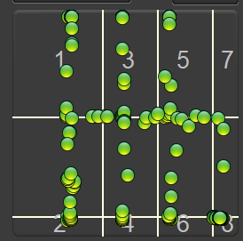

* Step 5: Drag/drop the vertical white lines such that when the shifter at a position, The green pot doesn’t That point does not overlap white lines.

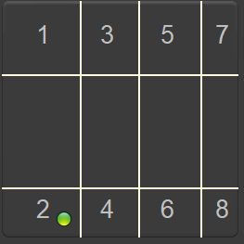

* Step 6: Click save
* Step 7: test again to make sure all gear position work.

### **2.3.2. Set the sequential thresholds**

* Step 1: Put the sequential plate to the shifter, switch to sequential mode
* Step 2: do like h-pattern setting with only 2 horizontal white lines
* Step 3: Click save
* Step 4: test again to make sure all gear position work.

## **2.4. Troubleshoot**

when plug the shifter into PC, ensure “analog mode” is checked to make the shifter work properly. If not, check it and save. Reconnect the shifter.

### **2.4.1. Cannot change the gear**

* + Step 1: Ensure “Select Report” combox is default value (Select Report)

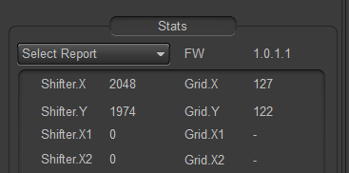

* + Step 2: if “Select Report” combox is default value, change its value to “shifter configuration”.
  + Step 3: Check min-max value, min < 1000, max > 3500, if not do calibration and set threshold again.
  + Step 3: Moving the shifter’s rod to check the green pod moving. Check when it stops at a gear, it overlaps white lines or not. If it overlaps, adjust the lines’ position
  + Step 4: if it still fails, capture the video and send us via email: [sale@vnmsimulation.com](mailto:sale@vnmsimulation.com)

## **2.5. Update firmware**

* Download update tool:

<https://github.com/hoantv/CarSimulatorFirmware/tree/master/Update%20tool>

* Download lastest firmware VNMShifter.hex in:

<https://github.com/hoantv/CarSimulatorFirmware/tree/master/shifter>

* Connect USB A to USB A to usbA port has icon upgrade, remove usb type B cable

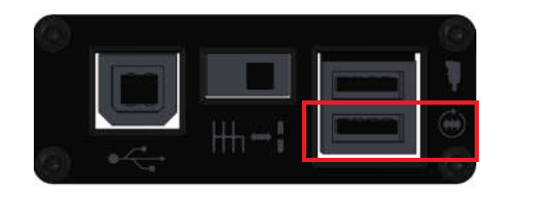

* Open tool after installing
* Click connect icon, it connect to MCU of the shifter.

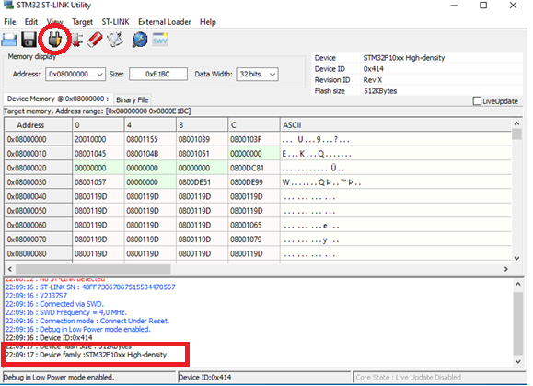

* Click “verify program” and browse to the VNMShifter.hex which was downloaded.

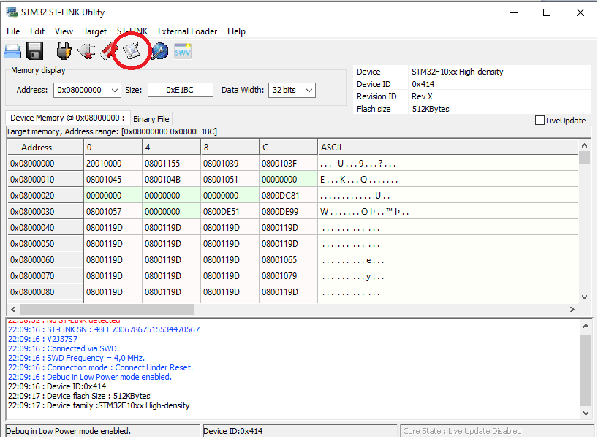

* Click start to upload firmware

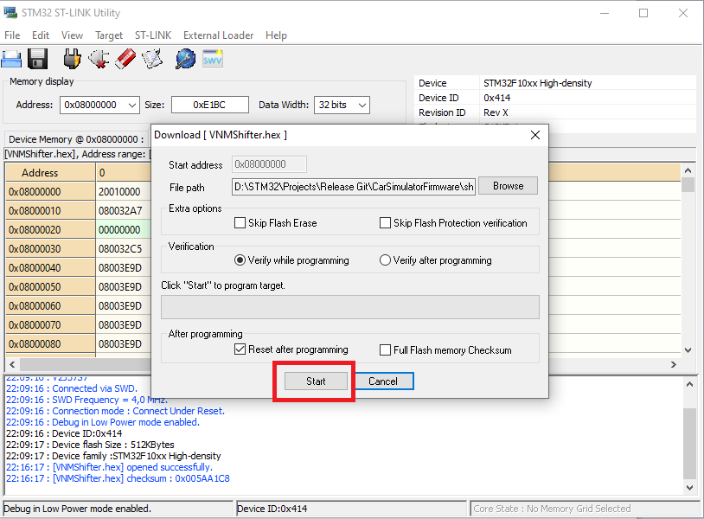

* Remove usb A to usb A cable, connect USB B to PC. Open the GUI, it displays the version equal to the version you have downloaded.

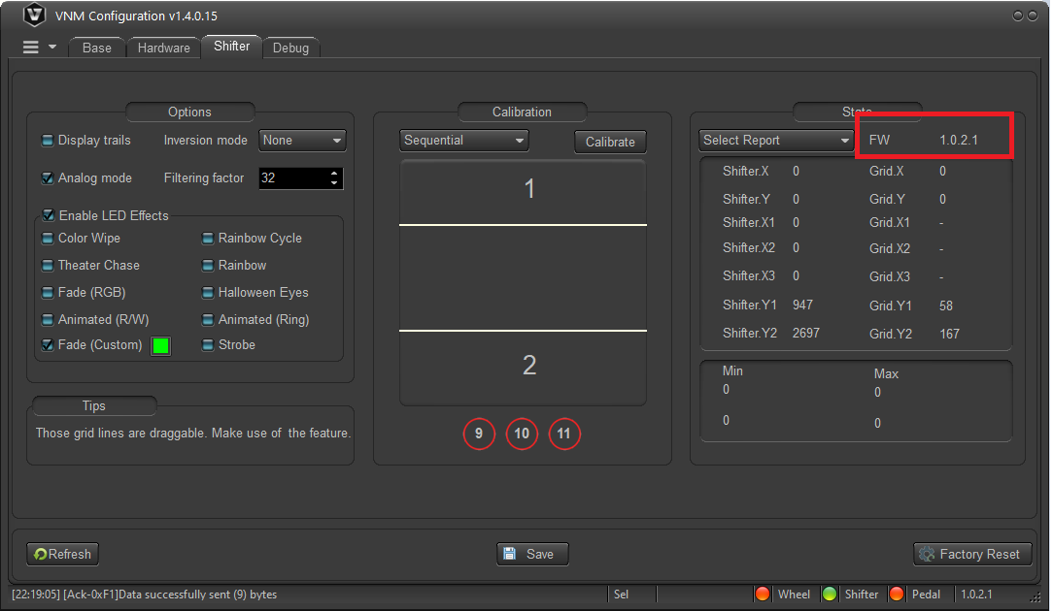

* Try the shifter, if having wrong gear when changing, do calibrate (usually don’t need)